Post # | Text | Link | Image
Post 1  Facebook Posts | Meth use can lead to social and emotional problems and can affect relationships with family and friends. Find out how: | http://drugaware.com.au/getting-the-facts/drug-types/amphetamines/#Campaign_videos | 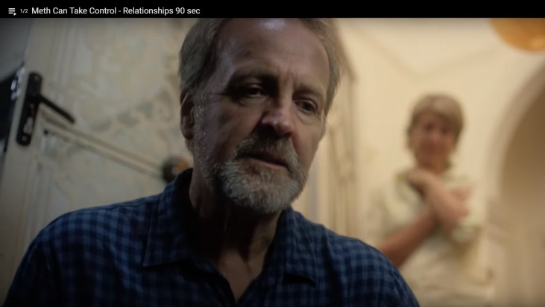
Post 2 | Meth is a stimulant drug which can impact on your health in the short and long-term and can lead to acute and chronic heart problems and stroke. See how Meth Can Take Control. | http://drugaware.com.au/getting-the-facts/drug-types/amphetamines/#Campaign_videos
Post 3 | In Western Australia, it is illegal to possess, use, manufacture, cultivate or supply an illicit drug.  Penalties can range from a $2,000 fine and/or a two-year prison term, to a $100,000 fine and/or imprisonment for 25 years.  Watch how: | http://drugaware.com.au/getting-the-facts/drug-types/amphetamines/#Campaign_videos
Post 4 | The Meth Helpline is a 24/7, WA state-wide telephone counseling, information and referral service for anyone concerned about their own, or another person’s meth use. You can contact the Meth Helpline on 1800 874 878 | http://drugaware.com.au/getting-help/how-to-get-help/#Meth-Helpline | 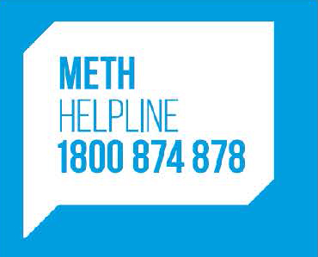
Post 5 | The Meth Helpline offers free professional drug counselling and advice, you can contact them via phone, email or live chat. | http://drugaware.com.au/getting-help/how-to-get-help/#Meth-Helpline | 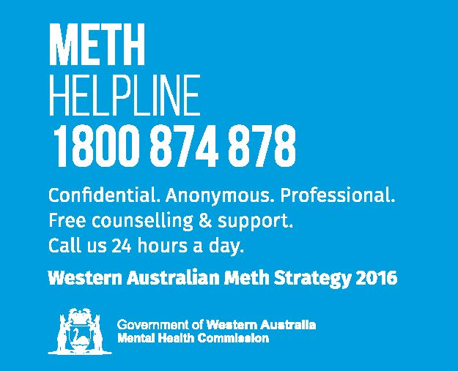
Post 6 | The counselling and support the Meth Helpline provides is free and non-judgemental. The helpline offers help and support for parents, family and friends who are concerned about a loved ones meth use. | http://drugaware.com.au/getting-help/how-to-get-help/#Meth-Helpline | 